Chương 1: Number systems and codes

Dạng 1: Dạng dữ liệu biểu diễn trên máy tính.

1.25 Represent the decimal number 6,248 in (a) BCD, (b) excess-3 code, (c) 2421 code, and (d) a 6311 code.

The answer:

a)BCD: 0110 0010 0100 1000

b) mã hóa 3: 1001 0101 0111 1011

|  |  |  |  |  |
| --- | --- | --- | --- | --- |
|  | **8** | **4** | **2** | **1** |
| **6(9-3)** | 1 | 0 | 0 | 1 |
| **2(5-3)** | 0 | 1 | 0 | 1 |
| **4(7-3)** | 0 | 1 | 1 | 1 |
| **8(11-3)** | 1 | 0 | 1 | 1 |

c) (6248)­­10 sang mã 2421: 1100 0010 0100 1110

|  |  |  |  |  |
| --- | --- | --- | --- | --- |
|  | **2** | **4** | **2** | **1** |
| **6** | 1 | 1 | 0 | 0 |
| **2** | 0 | 0 | 1 | 0 |
| **4** | 0 | 1 | 0 | 0 |
| **8** | 1 | 1 | 1 | 0 |

d) (6248)­­10 sang mã 6311: 1000 0011 0101 1011

|  |  |  |  |  |
| --- | --- | --- | --- | --- |
|  | **6** | **3** | **1** | **1** |
| **6** | 1 | 0 | 0 | 0 |
| **2** | 0 | 0 | 1 | 1 |
| **4** | 0 | 1 | 0 | 1 |
| **8** | 1 | 0 | 1 | 1 |

1.27 Assign a binary code in some orderly manner to the 52 playing cards. Use the minimum number of bit.

The answer:

25 =32 < 52, 26 = 64 >52 → 6 bits

The minimum number of bits for 52 cards is 6.

2bits first for: Heart(00), Tiles(01), Clovers(10), Pikes(11) 4 bits last for: 1-13 (Ace to K). example: Ace Pikes: 110001, K heart: 001101.

1.28 Write the expression "G. Boole in ASCIIL, using an eight-bit code. Include the period and the space. Treat the leftmost bit of each character as a parity bit. Each eigh-bit code should have odd parity. (George Boole was a 19th-century mathem atician. Boolean algebra, introduced in the next chapter, bears his name.

The answer

Write the expression "G. Boole” in ASCIIL**.**

G=71= 1 1000111

**. =** 46= 1 0101110

Space= 32= 0 0100000

B = 66 = 1 1000010

o= 111= 1 1101111

l= 108= 1 1101100

e=101=1 1100101

G. Boole=1 1000111 1 0101110 0 0100000 1 1000010 1 1101111 1 1101100 1 1100101

1.29 Decode the following ASCII code:

1010011 1110100 1 100101 1110110 1100101 0100000 1001010 1101111 11000 10 1110011.

The answer

128 64 32 16 8 4 2 1

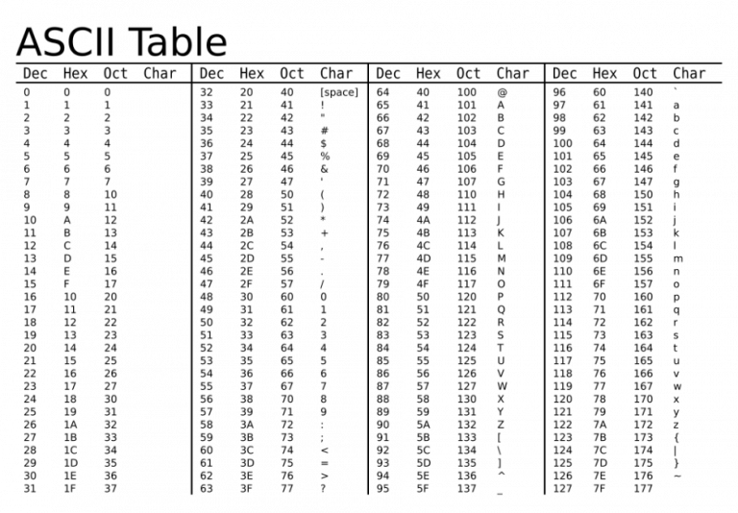

|  |  |  |
| --- | --- | --- |
| ASSII | Decimal | Char |
| 1010011 | 83 | S |
| 1110100 | 116 | t |
| 1100101 | 101 | e |
| 1110110 | 118 | v |
| 1100101 | 101 | e |
| 0100000 | 32 | space |
| 1001010 | 74 | J |
| 1101111 | 111 | o |
| 1100010 | 98 | b |
| 1110011 | 115 | s |

1.31 How many printing characters are there in ASCII? How many of them are special char-acters (not letters or numberals)?

The answer

- The graphic characters in the ASCII code that can be printed consist of the 26 uppercase letters (A through Z), the 26 lowercase letters (a through z), the 10 numerals (0 through 9), and 32 special printable characters, such as ~ , ! , @ , # , $ ,…

- Total number of printing characters in ASCII: 94

- Total number of special characters in ASCII: 32

1.34 List the ASCII code for the 10 decimal digits with an even parity bit in the leftmost position

The answer

(50): 1110010

(51): 0110011

(52): 1110100

(53): 0110101

(54): 0110110

(55): 1110111

(56): 1111000

(57): 0111001

(58): 0111010

(59): 1111011

Dạng 2: Các Đơn vị đo dữ liệu (bits, byte, word,…)

1.2* What is the exact number of bytes in a system that contains

a.32K bytes

b.64M bytes

c.6.4G bytes

The answer

**a.32K bytes**

1K= 210 =1024 b

32K= 32.210 = 32768 b

**b.64M bytes**

1MB = 1024 Kb = 10242 b

64 MB = 64. 10242 b = 67108864 b

**c.6.4G bytes**

1GB = 1024 MB = 10243 b

6,4 GB = 6,4.10243 b = 6871947674 b

1.32 What bit must be complemented to change an ASCII letter from capital to Lowercase and vice versa?

The answer

|  |  |  |  |
| --- | --- | --- | --- |
| 01000001 | A | 01100001 | a |
| 01000010 | B | 01100010 | b |
| 01000011 | C | 01100011 | c |
| 01000100 | D | 01100100 | d |
| 01000101 | E | 01100101 | e |
| 01000110 | F | 01100110 | f |
| 01000111 | G | 01100111 | g |
| 01001000 | H | 01101000 | h |
| 01001001 | I | 01101001 | i |
| 01001010 | J | 01101010 | j |
| 01001011 | K | 01101011 | k |
| 01001100 | L | 01101100 | l |
| 01001101 | M | 01101101 | m |
| 01001110 | N | 01101110 | n |
| 01001111 | O | 01101111 | o |
| 01010000 | P | 01101000 | p |
| 01010001 | Q | 01101001 | q |
| 01010010 | R | 01101010 | r |
| 01010011 | S | 01101011 | s |
| 01010100 | T | 01110100 | t |
| 01010101 | U | 01110101 | u |
| 01010110 | V | 01110110 | v |
| 01010111 | W | 01110111 | w |
| 01011000 | X | 01111000 | x |
| 01011001 | Y | 01111001 | y |
| 01011010 | Z | 01111010 | z |

0x61 is hexadecimal for 97 = a

0x41 is hexadecimal for 65 = A

=> subtraction or addition 32 is uppercase or lowercase

Z is 90 = 0b1111010

z is 122 = 0b1011010  
=> convert the sixth of bit to lowercase or uppercase

Dạng 3: So sánh sự khác nhau giữa ngôn ngữ bậc cao và bậc thấp

*Ngôn ngữ bậc cao: là ngôn ngữ trừu tượng cao trong ngôn ngữ máy tính ( machine learning).

*Ngôn ngữ bậc thấp: là ngôn ngữ liên quan chặt chẽ tới đến phần cứng của máy tính .

|  |  |  |  |  |  |  |  |  |  |  |  |  |  |  |  |
| --- | --- | --- | --- | --- | --- | --- | --- | --- | --- | --- | --- | --- | --- | --- | --- |
| |  |  |  | | --- | --- | --- | | Ngôn ngữ bậc cao | Ngôn ngữ bậc thấp | | | Thân thiện với người dùng | Gần gũi với máy tính để phát triển hệ điều hành hoặc viết mã | | Có tốc độ chậm | Có tốc độ nhanh | | | Có tính linh hoạt, dễ hiểu | Không linh hoạt, khó hiểu | | | Chủ yếu được sử dụng để viết phần mềm có thể chạy trên nhiều nền tảng và kiến trúc  VD: java, C/C++, python,ruby, visual basic,… | Code được viết cho một ngôn ngữ Assembly không thể chạy trên nền tảng khác  VD: Assembly | | |  |

Dạng 4: Các thành phần trong máy tính Computer (CPU, RAM, HĐ,BUS,…)

Dạng 5: Chuyển đổi qua lại giữa các hệ đếm

* 1. List the octal and hexadecimal numbers from 16 to 32. Using A and B for the last two digits, list the numbers from 8 to 28 in base 12

The answer

|  |  |  |  |  |  |  |  |  |  |  |  |  |  |  |  |  |  |
| --- | --- | --- | --- | --- | --- | --- | --- | --- | --- | --- | --- | --- | --- | --- | --- | --- | --- |
| Decimal | 16 | 17 | 18 | 19 | 20 | 21 | 22 | 23 | 24 | 25 | 26 | 27 | 28 | 29 | 30 | 31 | 32 |
| Octal | 20 | 21 | 22 | 23 | 24 | 25 | 26 | 27 | 30 | 31 | 32 | 33 | 34 | 35 | 36 | 37 | 40 |
| Hexadecimal | 10 | 11 | 12 | 13 | 14 | 15 | 16 | 17 | 18 | 19 | 1A | 1B | 1C | 1D | 1E | 1F | 20 |

|  |  |  |  |  |  |  |  |  |  |  |  |  |  |  |  |  |  |  |  |  |  |
| --- | --- | --- | --- | --- | --- | --- | --- | --- | --- | --- | --- | --- | --- | --- | --- | --- | --- | --- | --- | --- | --- |
| Decimal | 8 | 9 | 10 | 11 | 12 | 13 | 14 | 15 | 16 | 17 | 18 | 19 | 20 | 21 | 22 | 23 | 24 | 25 | 26 | 27 | 28 |
| Base 12 | 8 | 9 | A | B | 10 | 11 | 12 | 13 | 14 | 15 | 16 | 17 | 10 | 19 | 1A | 1B | 20 | 21 | 22 | 23 | 24 |

1.3 Convert the following numbers with the indicated bases to decimal:

a. (4310)5

b. (198)12

c. (435)8

d. (345)6

The answer

a. (4310)5 = 4x53+3x52+1x51+0x50 = (580)10

b. (198)12 = 1x122+9x121+8x120=(260)10

c. (435)8 = 4x82+3x81+5x80=(285)10

d. (345)6 = 3x62+4x61+5x60=(137)10

* 1. What is the largest binary number that can be expressed with 16 bits?

What are the equiv-alent decimal and hexadecimal numbers?

The answer

decimal: 65535; hexadecimal: (FFFF)16

* 1. Determine the base of the numbers in each case for the following operations to be correct:

1. 14/2=5
2. 54/4=13
3. 24+17=40

The answer:

* 1. Let the base is “b”:

14/2=5   
⬄(1 xb1 +4 x b0)/(2xb0)=5xb0

⬄(b+4)/2=5

⬄b/2+4/2=5  
 ⬄b=6

* 1. Let the base is “b”:

54/4=13

⬄(5xb1+4xb0)/4xb0=1xb1+3xb0

⬄(5b+4)/4=b+3

⬄b=8

c.Let the base is “b”:

24+17=40

⬄(2xb1+4xb0)+(1xb1+7xb0)=4xb1+0xb0

⬄3b+11=4b

⬄b=11

* 1. The solutions to the quadratic equation x2-11x+22 are x=3 and x=6. What is the base of the numbers?

The answer

*Give : x2 + 11x + 22 = 0. (1)

(-) (x-3)(x-6)=0

(-) x2 – 6x-3x + 3.6=0

(-) x2 – ( 3+6)x + 3.6=0 (2)

(1)(2) 🡪 3a0+6a0= 1a1+1a0

(-)3+6= a+1

(-) a = 8 🡪 **base of the numbers: 8.**

**1.7** Convert the hexadecimal number 64CD to binary, and then convert it from binary to octal.

The answer

Hexadecimal 🡪 binary: (64CD)16 = (0110 0100 1100 1101)2

Binary 🡪 octal : ( 0110 010 011 001 101)2= (062315)8

**1.8** Convert the decimal number 431 to binary in two ways:

(a) Convert directly to binary;

(b) Convert first to hexadecimal and then from hexadecimal to binary.

Which method is faster?

The answer

1. ${431}/2$ =215 🡪 1 ( b ). ${431}/{16}$ = 26 🡪 15

${215}/2$ =107 🡪 1 ${26}/{16}$ = 1 🡪 10

${107}/2=$ 53🡪1 ${10}/{16}$ = 0 🡪 1

${53}/2$ =26 🡪1

🡪 (431)10 = (1AF)16

=13 🡪 0

=6 🡪 1

=3 🡪0

= 1 🡪 1

=0 🡪1

🡪 (431)10 = (110101111)2

=>Phương pháp (b) nhanh hơn

**1.9** Express the following numbers in decimal:

(a) (10110.0101)2

(b) (16.5)16

(c) (26.24)8

(d) (DADA.B)16

(e) (1010.1101)2

The answer

(a) (10110.0101)2 =1x24 + 1x22 + 1x21 + 1x2-2 + 1x2-4 =(22.3125)10

(b) (16.5)16 = 1x161 + 6x160 + 5x16-1 = (22.3125)10

(c) (26.24)8 = 2x81 + 6x80 + 2x8-1 + 4x8-2 = (22.3125)10 (d) (DADA.B)16 = 13x163 + 10x162 + 13x161 + 10x160 + 11x16-1 = (56026.6875)10

(e) (1010.1101)2 = 1x23 + 1x21 +1x2-1 +1x2-2 +1x2-4 = (10.8125)10

**1.10** Convert the following binary numbers to hexadecimal and to decimal:

(a) 1.10010

(b) 110.010

Explain why the decimal answer in (b) is 4 times that in (a).

The answer

(1.10010)2=1 x 20 + 1 x 2-1 + 0 x 2-2 + 0 x 2-3 + 1 x 2-4 + 0 x 2-5

= 1 + 0.5 + 0.0625

= (1.5625)10

(110.010)2=1 x 22 + 1 x 21 + 0 x 20 + 0 x 2 -1 + 1 x 2-2 + 0 x 2-3

=4 + 2 + 0.25

= (6.25)10

Binary 🡪 Hexadecimal (Group 4)

(1.10010)2 = 0001.1001= (1.9)16

(110.010)2 = 0110.0100= (6.4)16

|  |  |  |
| --- | --- | --- |
| binary | Decimal | Hexadecimal |
| a) 1.10010 | 1.5625 | 1.9 |
| b) 110.010 | 6.25 | 6.4 |

The decimal answer in (b) is 4 times that in (a).

Cả 2 số nhị phân giống nhau nhưng khác ở dấu (.) ở câu b lùi qua phải 2 bit,

mà n bits 🡪 2n values

2 bits 🡪 22= 4 values

* Giá trị decimal ở b) gấp 4 lần ở a)

**1.11** Perform the following division in binary: 111011+ 101.

The answer

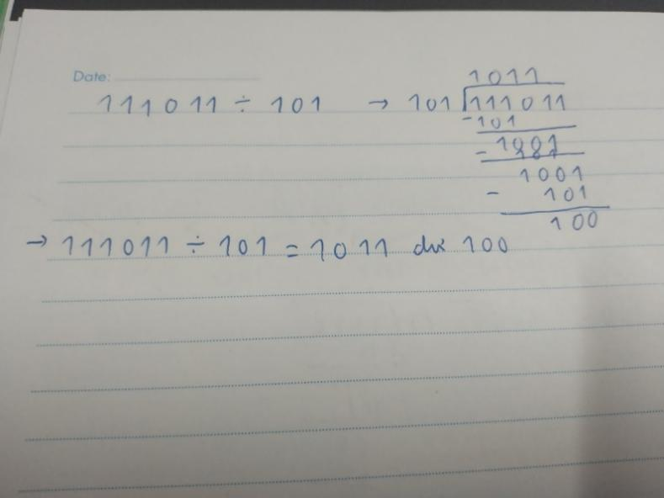

**1.12** Add and multiply the following numbers without converting them to decimal.

(a) Binary numbers 1011 and 101.

(b) Hexadecimal numbers 2E and 34.

The answer

a)

* (1011)2 + (101)2 = (10000)2

1011

+ 101

10000

* (1011)2 x (101)2­ = (110111)2

1011

x 101

1011

0000

1011

110111

(b)

* (2E)16 + (34)16 = (62)16
* (2E)16 x (34)16 = (958)16

2E

x 34

B8

8A

958

1.13 Do the following conversion problems:

(a) Convert decimal 27.315 to binary.

(b) Calculate the binary equivalent of 2/3 out to eight places. Then convert from binary to decimal. How close is the result to 2/3

(c) Convert the binary result in (b) into hexadecimal. Then convert the result to decimal. Is the answer the same?

The answer

a) 27 = 16 + 8 + 2 + 1 = 24 + 23 + 21 + 20

0.315

0.315 x 2 = 0.63 → 0

0.63 x 2 = 1.26 → 1

0.26 x 2 = 0.52 → 0

0.52 x 2 = 1.04 → 1

0.04 x 2 = 0.08 → 0

${(27.315)}_{10}$ = ${( 1 1 0 1 1 . 0 1 0 1 0 … )}_{2}$

b) 2/3= 0.66666667

• 0.66666667 × 2 = 1.33333334 → 1

• 0.33333334 × 2 = 0.66666668 → 0

• 0.66666668 × 2 = 1.33333336 → 1

• 0.33333336 × 2 = 0.66666672 → 0

• 0.66666672 × 2 = 1.33333344 → 1

• 0.33333344 × 2 = 0.66666688 → 0

• 0.66666688 × 2 = 1.33333376 → 1

• 0.33333376 × 2 = 0.66666752 → 0

• ……………….

➔ ${(0.66666667)}_{10}= {(0.10101010...)}_{2}$

${(0.10101010)}_{2}$ = ${1x2}^{−1}$ + 1x $2^{−3}$ + 1x $2^{−5}$ + 1x $2^{−7}$ = 0.6640625

c)

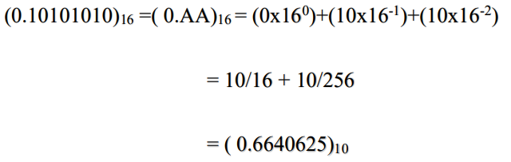

1.24 Formulate a weighted binary code for the decimal digits, using the following weights:

(a) 6,3,1,1

(b) 6,4,2,1

The answer

(a) 6,3,1,1

|  |  |  |  |  |
| --- | --- | --- | --- | --- |
|  | weighted binary code | | | |
| decimal | 6 | 3 | 1 | 1 |
| 0 | 0 | 0 | 0 | 0 |
| 1 | 0 | 0 | 0 | 1 |
| 2 | 0 | 0 | 1 | 1 |
| 3 | 0 | 1 | 0 | 0 |
| 4 | 0 | 1 | 0 | 1 |
| 5 | 0 | 1 | 1 | 1 |
| 6 | 1 | 0 | 0 | 0 |
| 7 | 1 | 0 | 0 | 1 |
| 8 | 1 | 0 | 1 | 1 |
| 9 | 1 | 1 | 0 | 0 |

(b) 6,4,2,1

|  |  |  |  |  |
| --- | --- | --- | --- | --- |
|  | weighted binary code | | | |
| decimal | 6 | 4 | 2 | 1 |
| 0 | 0 | 0 | 0 | 0 |
| 1 | 0 | 0 | 0 | 1 |
| 2 | 0 | 0 | 1 | 0 |
| 3 | 0 | 0 | 1 | 1 |
| 4 | 0 | 1 | 0 | 0 |
| 5 | 0 | 1 | 0 | 1 |
| 6 | 0 | 1 | 1 | 0 |
| 7 | 1 | 0 | 0 | 1 |
| 8 | 1 | 0 | 1 | 0 |
| 9 | 1 | 0 | 1 | 1 |

1.25 Represent the decimal number 6,248 in

(a) BCD

(B) excess-3 code

(c) 2421 code

(d) a 6311 code

The answer

1. 0110 0110 0100 1000BCD
2. 1001 0101 0111 1011
3. 1100 1000 0100 1110

1000 0011 0110 1011

1.30 The following is a string of ASCIl characters whose bit patterns have been converted into hexadecimal for compactness:73 F4 E5 76 ES 4A EF62 73. Of the eight bits in each pair of digits, the leftmost is a parity bit.The remaining bits are the ASCIl code. (a) Convert the string to bit fom and decode the ASCIL. (b) Determine the parity used: odd or even?

The answer

a)

7316=0111 00112 =>11100112 = 11510 => s

F416=1111 01002 =>111 01002 = 11610 => t

E516=1110 01012 =>110 01012 = 10110 =>e

7616=0111 01102 =>111 01102 = 11810 => v

E516=1110 01012 =>110 01012 = 10110 => e

4A16=0100 10102 =>100 10102 = 7410 => j

EF16=1110 11112 =>110 11112 = 11110 => o

6216=0110 00102 =>110 00102 = 9810 => b

7316=0111 00112 =>111 00112 = 11510 => s

b)

bit chẵn lẻ dạng lẻ

1.33 The state of a 12-bit register is 100010010111. What is its content if it represents

(a) Three decimal digits in BCD?

(b) Three decimal digits in the excess-3 code?

(c) Three decimal digits in the 84-2-1 code?

(d) A binary number?

The answer

a) Three decimal digits in BCD?

1000 = 23*1 + 22 *0 + 21 *0 + 20 *0 =8

1001 = 23*1 + 22 *0 + 21 *0 + 20 *1 =8+1=9

0111 = 23 *0 + 22 *1 + 21 *1 + 20 *1= 4+2+1=7

🡪897

(b) Three decimal digits in the excess-3 code?

1000 = 23*1 + 22 *0 + 21 *0 + 20 *0 =8-3=5

1001 = 23*1 + 22 *0 + 21 *0 + 20 *1 =8+1=9-3=6

0111 = 23 *0 + 22 *1 + 21 *1 + 20 *1= 4+2+1=7-3=4

🡪564

(c) Three decimal digits in the 84-2-1 code?

8 4 2 1

1 0 0 0 = 8

1 0 0 1 = 9 🡪897

0 1 1 1 = 7

(d) A binary number

(100010010111)2=211*1 + 210*0 +29*0 +28*0+27*1+26*0+25*0+24*1+23*0+22*1+21*1+20*1=2048+128+16+4+2+1=(2199)10

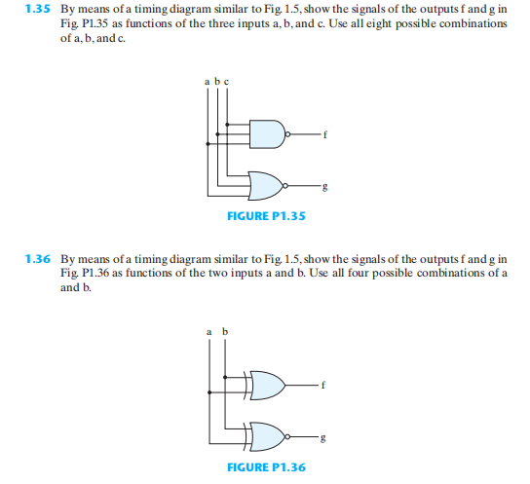

The answer

1.35

The Truth Table:

|  |  |  |  |  |
| --- | --- | --- | --- | --- |
| a | b | c | f [ (a•b•c)’ ] | g [ (a+b+c)’ ] |
| 0 | 0 | 0 | 1 | 1 |
| 0 | 0 | 1 | 1 | 0 |
| 0 | 1 | 0 | 1 | 0 |
| 0 | 1 | 1 | 1 | 0 |
| 1 | 0 | 0 | 1 | 0 |
| 1 | 0 | 1 | 1 | 0 |
| 1 | 1 | 0 | 1 | 0 |
| 1 | 1 | 1 | 0 | 0 |

Timing Diagram:

|  |  |  |  |  |  |  |  |  |
| --- | --- | --- | --- | --- | --- | --- | --- | --- |
| a |  |  |  |  |  |  |  |  |
|  |  |  |  |  |  |  |  |
| b |  |  |  |  |  |  |  |  |
|  |  |  |  |  |  |  |  |
| c |  |  |  |  |  |  |  |  |
|  |  |  |  |  |  |  |  |
| f |  |  |  |  |  |  |  |  |
|  |  |  |  |  |  |  |  |
| g |  |  |  |  |  |  |  |  |
|  |  |  |  |  |  |  |  |

1.36.

|  |  |  |  |
| --- | --- | --- | --- |
| a | b | f( or) | g( đối của f) |
| 0 | 0 | 0 | 1 |
| 0 | 1 | 1 | 0 |
| 1 | 0 | 1 | 0 |
| 1 | 1 | 1 | 0 |

Biểu đồ định thời:

|  |  |  |  |  |  |  |  |  |  |  |  |  |  |  |  |  |  |  |  |  |  |  |  |  |  |  |
| --- | --- | --- | --- | --- | --- | --- | --- | --- | --- | --- | --- | --- | --- | --- | --- | --- | --- | --- | --- | --- | --- | --- | --- | --- | --- | --- |
|  |  |  |  |  |  |  |  |  |  |  |  |  |  |  |  |  |  |  |  |  |  |  |  |  |  |  |
| a |  |  |  |  |  |  |  |  |  |  |  |  |  |  |  |  |  |  |  |  |  |  |  |  |  |  |
|  |  |  |  |  |  |  |  |  |  |  |  |  |  |  |  |  |  |  |  |  |  |  |  |  |  |
| b |  |  |  |  |  |  |  |  |  |  |  |  |  |  |  |  |  |  |  |  |  |  |  |  |  |  |
|  |  |  |  |  |  |  |  |  |  |  |  |  |  |  |  |  |  |  |  |  |  |  |  |  |  |
| f |  |  |  |  |  |  |  |  |  |  |  |  |  |  |  |  |  |  |  |  |  |  |  |  |  |  |
|  |  |  |  |  |  |  |  |  |  |  |  |  |  |  |  |  |  |  |  |  |  |  |  |  |  |
| g |  |  |  |  |  |  |  |  |  |  |  |  |  |  |  |  |  |  |  |  |  |  |  |  |  |  |
|  |  |  |  |  |  |  |  |  |  |  |  |  |  |  |  |  |  |  |  |  |  |  |  |  |  |
|  |  |  |  |  |  |  |  |  |  |  |  |  |  |  |  |  |  |  |  |  |  |  |  |  |  |  |



Dạng 6: Bù 1, Bù 2.

1.14 Obtain the 1’s and 2’s complements of the following binary numbers:

(a) 00010000

(b) 00000000

(c) 11011010

(d) 10101010

(e) 10000101

(f) 11111111

The answer

a) 00010000 = 000100001s = 000100002s

(b) 00000000 = 111111111s = 000000002s

(c) 11011010 = 001001011s = 001001102s

(d) 10101010 = 010101011s = 010111102s

(e) 10000101= 011110101s = 0111101102s

(f) 11111111=000000001s = 000000012s

1.15 Find the 9’s and the 10’s complement of the following decimal numbers:

(a) 25,478,036

(b) 63,325,600

(c) 25,000,000

(d) 00,000,000

The answer

(a) 25,478,036= 108-25,478,036= 74,521,96410s = 74,521,9639s

(b) 63,325,600 = 108-63,325,600= 36,674,40010s = 36,674,3999s

(c) 25,000,000 = 108-25,000,000=75,000,00010s=74,999,9999s

(d) 00,000,000 = 108-00,000,000=10,000,00010s=99999999s

1.16 (a) Find the 16’s complement of C3DF

(b) Convert C3DF to binary

(c) Find the 2’s complement of the result in (b)

(d) Convert the answer in (c) to hexadecimal and compare with the answer in (a).

The answer

a) Find 16's complement of C3DF 15's complement = FFFF – C3DF = 3C20

=>16's complement = 3C21

b) (C3DF)16 = (1100 0011 1101 1111)2

c) result in (b): 1100 0011 1101 1111

1’s complement : 0011 1100 0010 0000

2’s complement: 0011 1100 0010 0001

d) result in (c): 0011 1100 0011 0001 to hexadecimal: 3C21

|  |  |  |  |
| --- | --- | --- | --- |
| 8 | 4 | 2 | 1 |
| 0 | 0 | 1 | 1 |
| 1 | 1 | 0 | 0 |
| 0 | 0 | 1 | 1 |
| 0 | 0 | 0 | 1 |

Compare with the answer in a: C=A

1.17 Perform subtraction on the given unsigned numbers using the 10’s complement of the subtrahend.Where the result should be negative, find its 10’s complement and affix a minus sign. Verify your answers.

(a) 4,637 - 2,579

(b) 125 - 1,800

(c) 2,043 - 4,361

(d) 1,631 - 745

The answer

(a) 4637-2579:  
Ta có: -2579=74209’s=742110’s

4637

+

7421

1 2058

(b) 125-1800:  
Ta có: -1800=81999’s=820010’s

125

+

8200

8325=16749’s=-167510’s

(c) 2043-4361:  
Ta có: -4361=56389’s=563910’s

2043

+  
 5639

7682=23179’s=-231810’s

(d) 1631-745:

-745=92549’s=925510’s

1631

+

9255

1 0886

Ta có: -745=92549’s=925510’s 1631

9255 1 0886

1.18 Perform subtraction on the given usigned binary numbers using the 2’s complement of the subtrahend. Where the result should be negative. Find its 2’s complement and affix a minussign.

(a) 1011 - 10010

(b) 100010 - 100110

(c) 1001 - 110101

(d) 101000 - 10101

The answer

a)1011-10010=(1011)2+((01101)1s+1))2s=1011+1110=(1001)2s =(1000)1s =-(111)2 =-7

b)100010-100110=(100010)2 +((011001)1s +1))2s =100010+011010=(111100)2s =(111011)1s =-(000100)2 =-4

c)1001-110101=(1001)2 +((1010)+1))=1001+1011=(10100)2s =(10011)1s =-(101100)2 =-44

d)101000-10101=(101000)2 +(101010+1)2s =(010011)2s =19

1.19 The following decimal numbers are shown in sign-magnitude form: +9,286 and +801. Convert them to signed-10’s-complement form and perform the following operations ( note that the sum is +10,627 and requires five digits and a sign)

1. (a)(+9,286) + (+801)
2. (+9,286) +(-801)
3. (-9,296) + (-801)

The answer

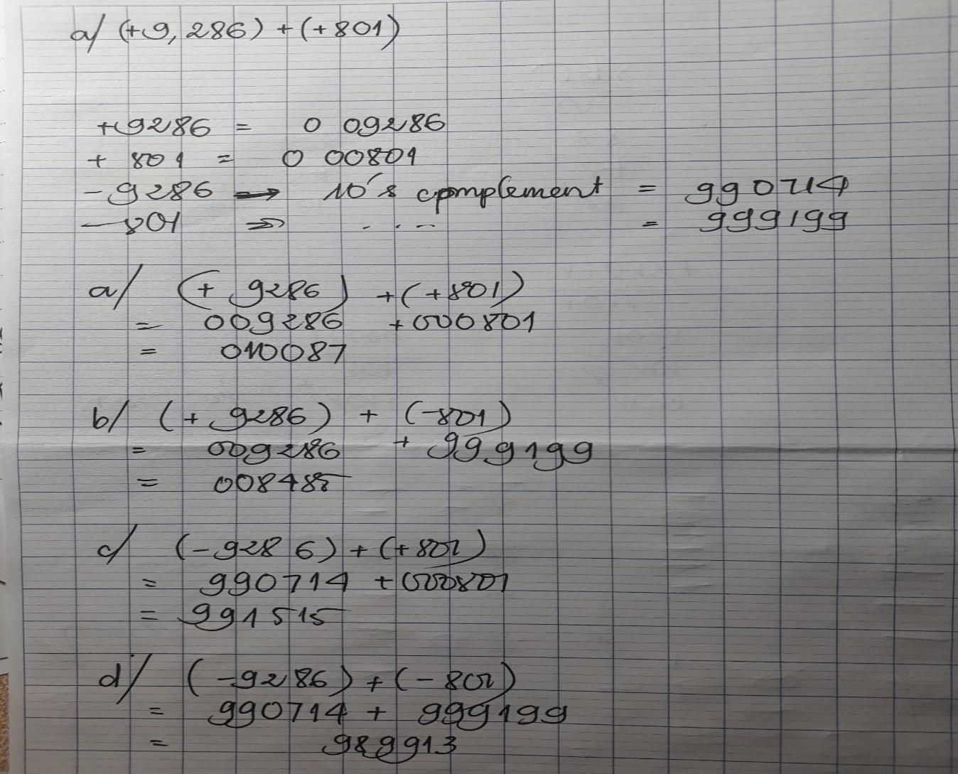

1.26 Find the 9's complement of decimal 6,248 and express it in 2421 code. Show that the result is the 1's complement of the answer to (c) in CR_PROBlem 1.25. This demonstrates that the 2421 code is self-complementing.

The answer

Phần bù 9 của 624810 là 3751 (9999-6248=3751) = 1001 0111 0101 00012421 (1)

Kết quả đáp án 1.25c : 1100 1000 0100 11102421 = 0110 1000 1010 11102421 (2)

Khi lấy bù 1 của (2) ta được (1)